Mapping the Pain: My Migraine Journey Through Data
I am particularly interested in how data analysis can be used to help solve real world problems. This even extends to those in my personal life. Here, I used data analysis to better understand my migraines.
Migraines affect millions of people worldwide, yet their triggers and patterns often remain highly individual and difficult to pinpoint. Over the course of ten months, I collected and recorded my own daily migraine data — tracking various lifestyle and environmental factors such as sleep, stress, screen time, skipped meals, water consumption, physical activity, and exposure to loud noise. Using Excel and Tableau, I aimed to identify potential correlations between these variables and my migraine occurrences.
Although I did not find any significant relationship between migraines and factors like screen time, skipped meals, hours of sleep, starting time, or day of the week, my analysis revealed several meaningful insights worth highlighting.

The data reveals a clear and consistent relationship between hydration and migraine occurrence. Insufficient water intake was present on 95% of migraine days, while adequate hydration was observed on 100% of migraine-free days. This strong inverse correlation suggests that hydration status may play a critical preventive role, positioning water consumption as one of the most influential lifestyle factors in mitigating migraine risk in my case.
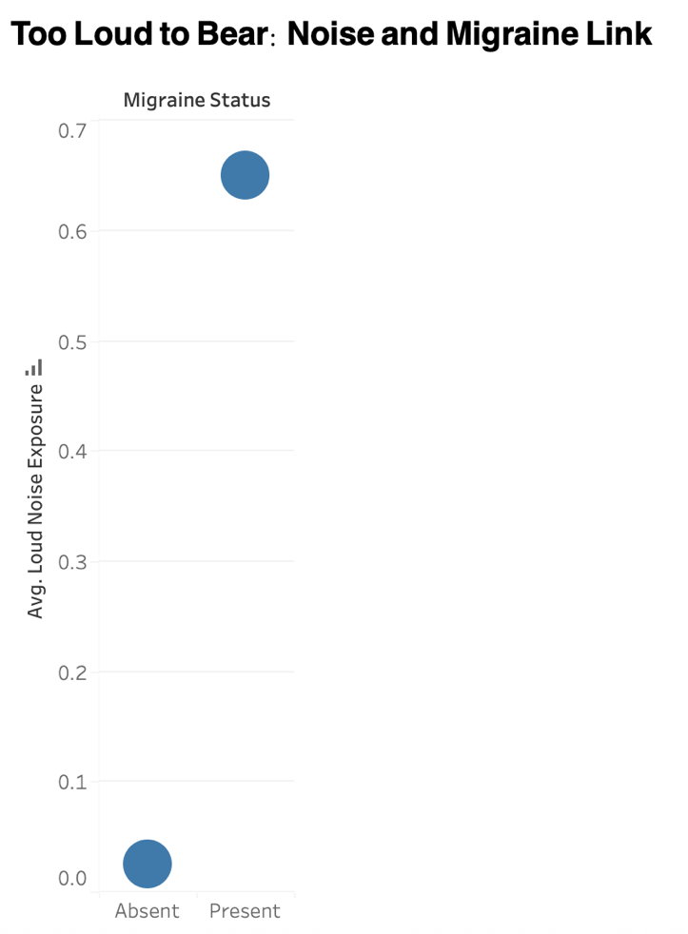
Exposure to loud noise also showed a clear association with migraine occurrence. The average loud noise exposure level was significantly higher on migraine days, while it was nearly absent on migraine-free days. This pattern suggests that environmental noise may act as a strong external trigger, emphasising the importance of quiet surroundings in migraine prevention and management.

Among migraine-experiencing days, pain severity was inversely related to physical activity. The average severity reached around 8 when no activity was performed, dropping to about 4 with moderate activity and near 2 with high activity. This clear gradient suggests that maintaining regular physical movement may help alleviate migraine intensity and serve as a protective behavioural factor.
Conclusion
This ten-month analysis revealed that hydration, noise, and physical activity were the most influential factors linked to my migraines. Staying well-hydrated, avoiding loud environments, and keeping an active routine appear to significantly reduce both the likelihood and intensity of migraine episodes.

